Fitter Futures Warwickshire – Swap to Stop suggested copy + assets
Suggested copy | Social asset
Join the millions of adults across the UK who are going #Smokefree with a Quit Kit. 🚭  1 in 10 ex-smokers have said they’ve successfully quit smoking with the help of an e-cigarette.  For free personalised support and advice from our specialist smoking practitioners, plus your own Quit Kit, visit: 🔗https://fitterfutures.everyonehealth.co.uk/stop-smoking-service/ or text QUIT to 60777. | 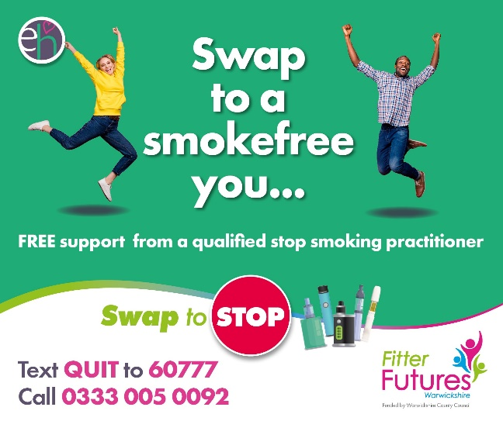
Trade in your pack of cigarettes for a Quit Kit! 🔁  64% of ex-smokers have said they used e-cigarettes, alongside behavioural support from a specialist stop smoking practitioner to go and remain smokefree.  Fitter Futures #Warwickshire offer 12 weeks of FREE 1-1 support, plus a variety of stop smoking treatments so you can be on the road to a #Smokefree life. 🚭  Visit: 🔗https://fitterfutures.everyonehealth.co.uk/stop-smoking-service/ or text QUIT to 60777 to sign-up today. | 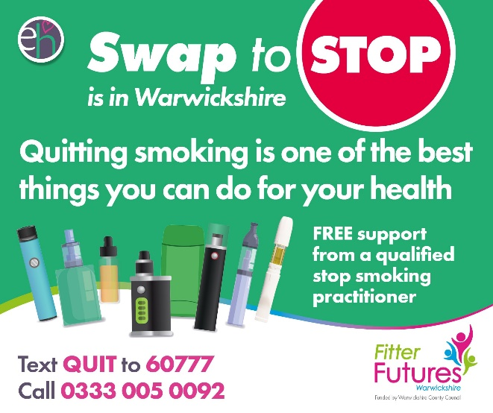
Could you be entitled to FREE Stop Smoking support? 🚭  Fitter Futures Warwickshire offers 12 weeks of free Stop Smoking specialist support and advice from our practitioners, plus stop smoking treatments such as lozenges, patches and Quit Kits across #Warwickshire.  Visit: 🔗https://fitterfutures.everyonehealth.co.uk/stop-smoking-service/ to check your eligibility. | 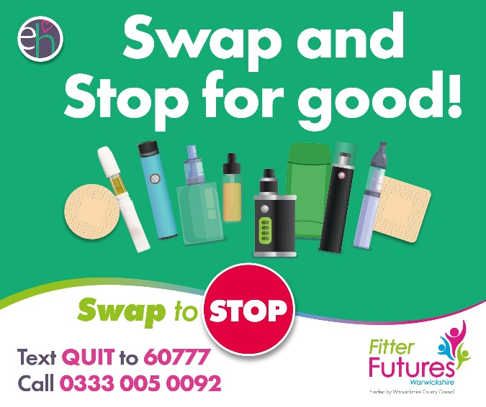
Cigarettes prices are continuing to rocket with a pack of 20 now standing at an eye-watering £14.57. 💰  Start to mend your financial and physical health with #Warwickshire’s FREE Stop Smoking support service.  For personalised support and advice from our specialist practitioners, as well as FREE stop smoking treatments such as patches or Quit Kits, visit: 🔗https://fitterfutures.everyonehealth.co.uk/stop-smoking-service/ or text QUIT to 60777. | 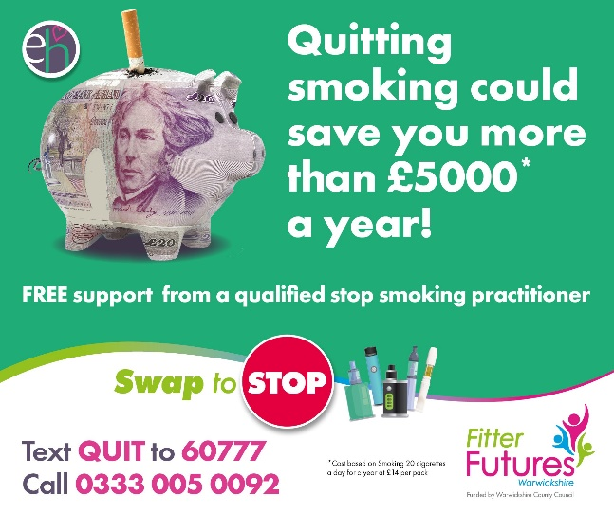
Trade in sleepless nights for a full 8 hours! 💤  Smoking has been linked to poor sleep as nicotine can disrupt your sleep cycle.  Doze off with the help of our free Stop Smoking support service. For personalised 1-1 support, advice, plus stop smoking treatments such as patches and Quit Kits, text QUIT to 60777 or visit: 🔗https://fitterfutures.everyonehealth.co.uk/stop-smoking-service/. | 